A MINOR PROJECT REPORT

ON

**3-D REAL ESTATE WALKTHROUGH**

**BACHELOR OF TECHNOLOGY**

**IN**

**ELECTRONICS AND COMMUNICATION ENGINEERING**



**Submitted By Under the supervision of:**

1. M. TIPPU JANI (9918102080) DR. JITENDRA MOHAN

VIMAL KUMAR (9918102146)

YASH JINDAL (9918102147)

**DEPARTMENT OF ELECTRONICS AND COMMUNICATION ENGINEERING**

**JAYPEE INSTITUTE OF INFORMATION TECHNOLOGY**

**NOIDA (U.P)**

**May, 2021**

# CERTIFICATE

This is to certify that the minor project report entitled, “**3-Dimensional Real Estate Walkthrough**” submitted by **S.M. Tippu Jani, Vimal Kumar and Yash Jindal** in partial fulfillment of the requirements for the award of Bachelor of Technology Degree in **Electronics and Communication Engineering** of the Jaypee Institute of Information Technology, Noida is an authentic work carried out by them under my supervision and guidance. The matter embodied in this report is original and has not been submitted for the award of any other degree.

#### Signature of Supervisor:

#### Dr. Jitendra Mohan

#### ECE Department,

**JIIT NOIDA**

May, 2021

# DECLARATION

We hereby declare that this written submission represents our own ideas in our own words and where others ideas or words have been included, have adequately cited and referenced the original sources. We also declare that we have adhered to all principles of academic honesty and integrity and have not misrepresented or fabricated or falsified any idea/data/fact/source in our submission.

Place: JIIT Noida **Name**: S.M. Tippu Jani

Date: 12th May,2021 **Enrollment:**9918102080(E4)

**Name**: Vimal Kumar

**Enrollment**:9918102146(E4)

**Name**: Yash Jindal

**Enrollment**:9918102147(E4)

# ABSTRACT

In 3-D computer graphics, 3-D modeling is the process of developing a mathematical representation of any surface of an object (inanimate or living) in three dimensions via specialized software. The product is called a 3-D model. The person who works with 3-D models is referred as a 3-D artist. It can be displayed as a two-dimensional image through a process called 3-D rendering or used in a computer simulation of physical phenomena. The model can also be physically created using 3-D printing devices. In terms of game development, 3-D modeling is merely a stage in the entire development process. Models may be created automatically or manually. The manual modeling process of preparing geometric data for 3-D computer graphics is similar to plastic arts such as sculpting. Three-dimensional (3-D) models represent a physical body using a collection of points in 3-D space, connected by various geometric entities such as triangles, lines, curved surfaces, etc. Being a collection of data (points and other information), 3-D models can be created manually, algorithmically (procedural modeling), or by scanning. Their surfaces may be further defined with texture mapping. 3-D models are widely used anywhere in 3-D graphics and CAD. Their use predates the widespread use of 3-D graphics on personal computers. Many computer games used pre- rendered images of 3-D models as sprites before computers could render them in real- time. The designer can then see the model in various directions and views; this can help the designer see if the object is created as intended to compare to their original vision. Seeing the design this way can help the designer or company Figure out changes or improvements needed to the product.

**ACKNOWLEDGMENT**

We place on record and heartily recognize the ceaseless support, significant oversight, convenient recommendations and motivated direction offered by our project mentor Dr. Jitendra Mohan, Department of Electronics and Communication Engineering at Jaypee Institute of Information Technology Sector-128 in bringing this report to a successful completion. We are appreciative of our Minor project coordinator Mr. Raghvenda Kumar Singh to make the offices accessible in the Department to complete the project effectively. To wrap things up we express our earnest gratitude to every one of our companions who have calmly broaden a wide range of help for achieving this endeavor.

**Name:** S.M. Tippu Jani

**Enrollment:** 9918102080

**Name:** Vimal Kumar **Enrollment:** 9918102146

**Name:** Yash Jindal **Enrollment:** 9918102147

May, 2021

|  |  |  |  |  |
| --- | --- | --- | --- | --- |
| **TABLE OF CONTENTS** | | | | |
| **S. No.** | **Title** | | | **Page No.** |
|  | **Certificate** | | | **ii** |
|  | **Declaration** | | | **iii** |
|  | **Abstract** | | | **iv** |
|  | **Acknowledgement** | | | **v** |
|  | **Table of Contents** | | | **vi** |
|  | **List of Figures** | | | **viii** |
| **1.** | **Introduction and Literature Survey** | | | **1** |
|  | 1.1 | Introduction | | 1 |
|  |  | 1.1.1 | 3-D Modelling | 1 |
|  |  | 1.1.2 | Web Development | 2 |
|  | 1.2 | Literature Survey | | 2 |
| **2.** | **Implementation** | | | **3** |
|  | 2.1 | Design Approach | | **3** |
|  |  | 2.1.1 | Modified Waterfall Model | 3 |
|  |  | 2.1.1 | Advantages of Waterfall Model | 4 |
|  | 2.2 | Languages Used | | 4 |
|  |  | 2.1.1 | HTML5 | 4 |
|  |  | 2.1.1 | CSS | 4 |
|  |  | 2.1.1 | JavaScript | 5 |
|  | 2.3 | Blender | | 5 |
|  |  | 2.3.1 | Modelling | 6 |
| 2.3.2 | Animation | 6 |
| 2.3.3 | Rendering | 7 |
| 2.3.4 | Video Editing | 7 |
| 2.3.5 | Game Creation | 7 |
| 2.3.6 | Scripting | 7 |
| **3** | **Flowchart and 3d modelling** | | | **8** |
|  | 31 | Flowchart | | 8 |
|  | 3.2 | Activity Diagram | | 9 |
|  | 3.3 | 3-D Modelling | | 10 |
|  |  | 3.3.1 | 3-D modelling of house in Blender | 10 |
| 3.3.2 | 3D Render of a Demo Unit | 11 |
| 3.3.3 | Proposed Output of the House model | 12 |
| **4.** | **Website Snapshots** | | | **15** |
|  | 4.1 | Homepage | | 15 |
|  | 4.2 | Demo Property | | 16 |
| **5.** | **Features and Applications** | | | **17** |
|  | 5.1 | Features | | 17 |
|  |  | 5.1.1 | At Home Service | 17 |
|  |  | 5.1.2 | Numerous Properties available | 17 |
|  | 5.2 | Applications | | 17 |
|  |  | 5.2.1 | Architecture Simulation | 17 |
| 5.2.2 | Prediction through Machine Learning | 17 |
| **6.** | **Conclusion and Future Scope** | | | **18** |
|  | 6.1 | Conclusion | | 18 |
|  | 6.2 | Future Scope | | 18 |
|  | **References** |  | | 19 |
|  | **Appendix** |  | | 20 |

|  |  |  |
| --- | --- | --- |
| **LIST OF FIGURES** | | |
| **S. No.** | **Title** | **Page No.** |
| **Fig 2.1** | Modified Waterfall Model | 3 |
| **Fig 2.2** | Bender Animation UI | 6 |
| **Fig 4.1** | Flowchart | 8 |
| **Fig 4.2** | Activity Diagram | 9 |
| **Fig 4.3** | Side View of House Model (1) | 10 |
| **Fig 4.4** | Side View of House Model (2) | 10 |
| **Fig 4.5** | Top View of Rendered Model | 11 |
| **Fig 4.6** | Inside View of Rendered Model | 11 |
| **Fig 4.7** | Proposed House Model (1) | 12 |
| **Fig 4.8** | Proposed House Model (2) | 13 |
| **Fig 4.9** | Proposed House Model (3) | 14 |
| **Fig 5.1** | Homepage (1) | 15 |
| **Fig 5.2** | Homepage (2) | 15 |
| **Fig 5.3** | Homepage (3) | 16 |
| **Fig 5.4** | Demo Property Webpage | 16 |
|  |  |  |
|  |  |  |

**CHAPTER 1**

**INTRODUCTION AND LITERATURE SURVEY**

**1.1 Introduction**

Real Estate has always been a huge sector in any countries economy. Real Estate Builders have always show interest in buying land in huge cities and build their mega projects for people to move in.

The different kinds of houses are as follows:

* **Apartment or Flat** – An individual unit in a multi-unit building. The boundaries of the apartment are generally defined by a perimeter of locked or lockable doors.
* **Terraced House** – A number of single or multi-unit buildings in a continuous row with shared walls and no intervening space.
* **Condominium** – A building or complex, similar to apartments, owned by individuals. Common grounds and common areas within the complex are owned and shared jointly. In North America, there are *townhouse* or *rowhouse* style condominiums as well. The British equivalent is a block of flats.
* **Cooperative** – A type of multiple ownership in which the residents of a multi-unit housing complex own shares in the cooperative corporation that owns the property, giving each resident the right to occupy a specific apartment or unit.

**1.1.1 3-D Modelling**

* 3-D Design is a cracking tool for architects to execute their design gigs. It will come in handy for architects to outline a building’s structure and know in advance how a building will look once engineers, builders, and masons construct the building. 3-D designers or CAD designers contribute considerably when it comes to creating real estate designs virtually. The major upside of 3-D design is that it provides the clients heartfelt contentment and conviction as they know this is how his property will look.

**1.1.2 Web Development**

* Web development is the building and maintenance of websites; it's the work that happens behind the scenes to make a website look great, work fast and perform well with a seamless user experience. Web developers, or 'Devs', do this by using a variety of coding languages.

**1.2 Literature Survey**

The purpose was to consider the viability and possibilities of Virtual Reality being used as a marketing tool in Real Estate. One of the key approaches was to consider what’s happening with Virtual Reality right now. It also illustrates the history of in-house technological attempts at creating appropriate presentation tools for real estate properties with 3D and VR[4]. Reflecting and focus on the industry of Real Estate and to go back to the beginning of how real estate began and how it has evolved over time with particular reflection on how technology has influenced and assisted the evolvement of the real estate industry. It has also been important to consider to remain central to the fact that Real Estate is all about the seller, the buyer and the intermediary fundamentals[5]. The literature survey is broken down into four sections:

1. Virtual Reality.

2. Evolution of Real Estate Agency Operations.

3. Impact of VR on behaviour of customers wishing to engage in Real Estate purchases.

4. Impact of VR on strategies adopted by real estate agency for online sales

To assist in the understanding of the workings of electronic commerce and its applicability to SMEs, models of the activity have been examined[1]. The current e-Commerce frameworks and/ or models in the literature seem to come from differing perspectives presenting a range of varying elements.

Chan and Swatman (1999) have developed a dynamic model of e- Commerce, representative of all e-Commerce types, activities and capabilities that demonstrate its performance in product and service terms[2]. The complexity of the framework is modelled into a fluid representation of the varying viewpoints of the stakeholders .

The boundaries are fluid; subsequently the size of each area is determined by the specific views of the parties involved. Any alteration of the borders does not affect the actual weight of the components within the model. The model also allows for changes over time as objects may be added to or removed from the basic components.[3]

**CHAPTER 2**

**IMPLEMENTATION**

**2.1 Design Approach**

**2.1.1 Modified Waterfall Model:**

The modified waterfall model as shown in Fig 2.1 uses the same phases as the pure waterfall model. In response to the perceived problems with the pure waterfall model, modified waterfall model has been introduced. This enables the phases to overlap when needed. This is selected because our requirements for the projects were clear; it is a small project and hence can be implemented step by step.

The rigidity of the Waterfall model aids project management with well-defined milestones and deliverables. It does however restrict flexibility and does not provide much scope for user feedback until software development has been completed. It is only suitable for insular projects where user requirements can be clearly defined at the outset and are unlikely to change over the software lifespan.

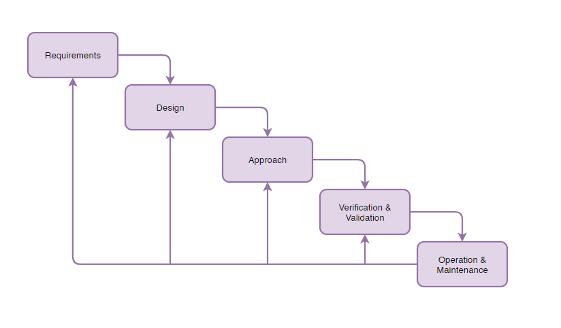Fig 2.1: Modified Waterfall Model

**2.1.2 Advantages of waterfall model**

* This model is simple and easy to understand and use.
* It is easy to manage due to the rigidity of the model – each phase has specific deliverables and a review process.
* In this model phases are processed and completed one at a time. Phases do not overlap.
* Waterfall model works well for smaller projects where requirements are clearly defined and very well understood.

**2.2 Languages Used**

**2.2.1 HTML5**

* HTML5 is a markup language used for structuring and presenting content on the World Wide Web. It is the fifth and latest major version of HTML that is a World Wide Web Consortium (W3C) recommendation.
* Many new syntactic features are included. To natively include and handle multimedia and graphical content, the new, and elements were added, and support for scalable vector graphics (SVG) content and MathML for mathematical formulas was also added.

**2.2.2 CSS**

* Cascading Style Sheets (CSS) is a style sheet language used for describing the presentation of a document written in a markup language like HTML. CSS is a cornerstone technology of the World Wide Web, alongside HTML and JavaScript.
* CSS is designed to enable the separation of presentation and content, including layout, colors, and fonts. This separation can improve content accessibility, provide more flexibility and control in the specification of presentation characteristics, and enable multiple web pages to share formatting by specifying the relevant CSS in a separate.
* CSS has a simple syntax and uses a number of English keywords to specify the names of various style properties.
* In CSS, selectors declare which part of the markup a style applies to by matching tags and attributes in the markup itself.

**2.2.3 JavaScript**

* + Alongside HTML and CSS, JavaScript is one of the core technologies of the World Wide Web. JavaScript enables interactive web pages and is an essential part of web applications. The vast majority of websites use it for client-side page behavior, and all major web browsers have a dedicated JavaScript engine to execute it.
  + JavaScript is the dominant client-side scripting language of the Web, with 95% of websites using it for this purpose. Scripts are embedded in or included from HTML documents and interact with the DOM. All major web browsers have a built-in JavaScript engine that executes the code on the user's device.
  + JQuery is the most popular library used by over 70% of Websites.

**2.3 Software Used**

Blender is an open source and best 3D animation learning software for both fresher’s and experience to work for any complicated animation or gaming concept with simple handling tools. So far many artists use blender tools for their projects for best and cost less & professional skill approach to impress their clients with work. Here are a few features of Blender 3D. A UI snapshot of blender 3-D is shown in Fig 2.2.

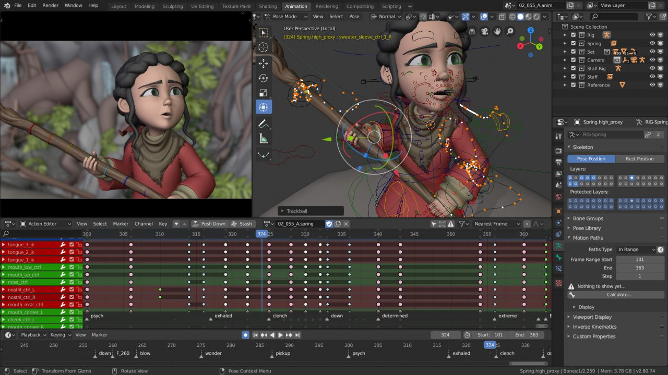

Fig 2.2 Bender Animation UI

*Source:https://www.blender.org/wp-content/uploads/2019/07/animation01-1280x720.jpg?x20228*

**2.3.1 Modelling**

It is the basis for creating game environments and animation characters and probes models are designed using the combinations of points, lines and polygons, and their shapes to get the nearest shape of the design and brushes are used to deposit material in required using different deposition quality. Modifiers are automatic operations that affect the object in a dissenting way of editing. We can perform curving, smoothing and many other effective surface related edits to blend our model. UV Unwrapping is a must for modelling through which we can apply textures to our models. Texturing can be done using Photoshop or also even UV sculpt to add colours to the models.

**2.3.2 Animation**

It is a process of adding motions to character with help of keys, nonlinear animation can be easy, automatic walk cycles can be set, character animation editor is available where we can instantly see the animation on rendered screen with fast rigging options. Mirror functionality easy painting, Skeleton, and automatic skinning options, bone and spin making and movements can be interpolated easily.

**2.3.3 Rendering**

A much-needed task in animation handling software’s and also, we need a good CPU and Graphics car to handle or get renders done quick. Geometry mesh handling, BVH build and fit updates can be done. Texturing, cam handling, lighting, surface modelling, shading and many more can be adjusted and make the best frame out of the work.

**2.3.4 Video Editing**

It allows to perform basic actions like splicing, cutting, speeding and slowing, live preview, Lumia waveform, Chroma vector scope, Audio mixing, Syncing, Scrubbing, Visualizing, adding 32 slots of image, video, and effects, adjusting layers and keyframe filters and transformations and more.

**2.3.5 Game Creation**

Full functional creative tools and stuff is built in a blender with the gaming engine functions such as Porting models applying codes and own game logic, complete physical integration and python scripting with advanced controls and AI. All open GL dynamic lighting, Shading, animatic materials, and mapping. 3d Spatial audio using Open AL.

**2.3.6 Scripting**

The blender comes with loaded scripting array of extensions with quick on and off modes which help in generating trees, terrains, clouds and few regular probes, 3d printing Toolbox. Importing and exporting multiple file formats.

**CHAPTER 3**

**FLOWCHART AND 3D MODELLING**

**3.1 Flowchart:**

The flow chart in the Fig 3.1 shows the composition of the project and how the backend and frontend come together to complete the project. There are many components being used to provide a better user experience

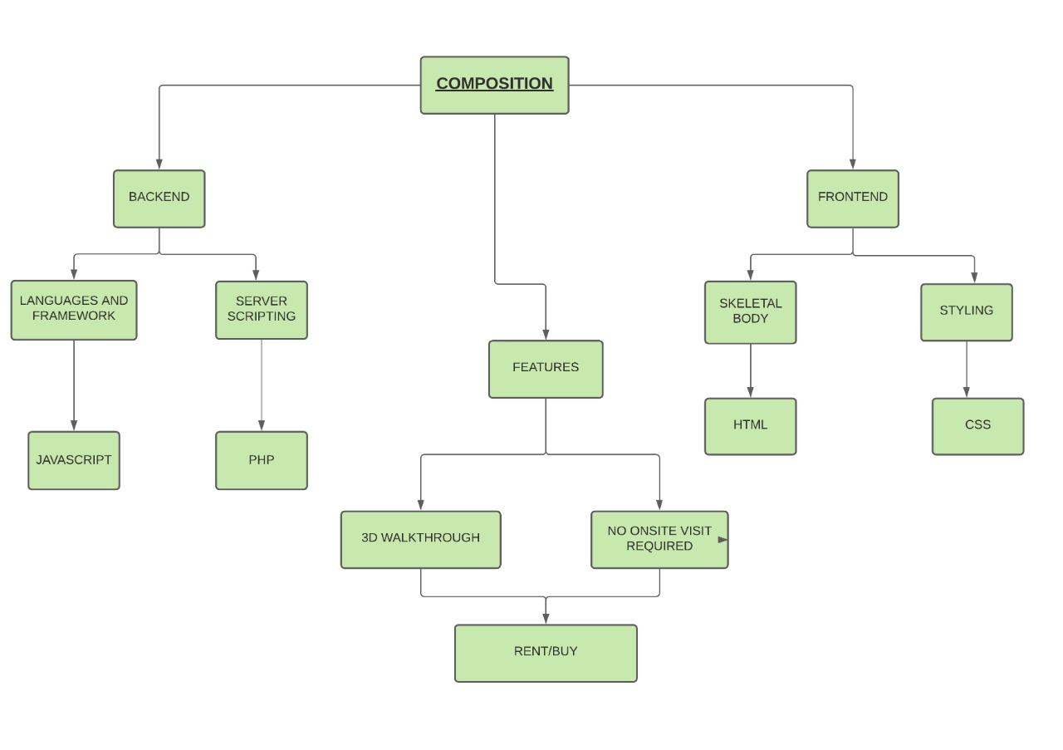

Fig 3.1: Flowchart

**3.2 Activity Diagram:**

This graph in Fig 3.2 shows how a user will interact with the website and the various steps that are included in a successful purchase from the website**.**

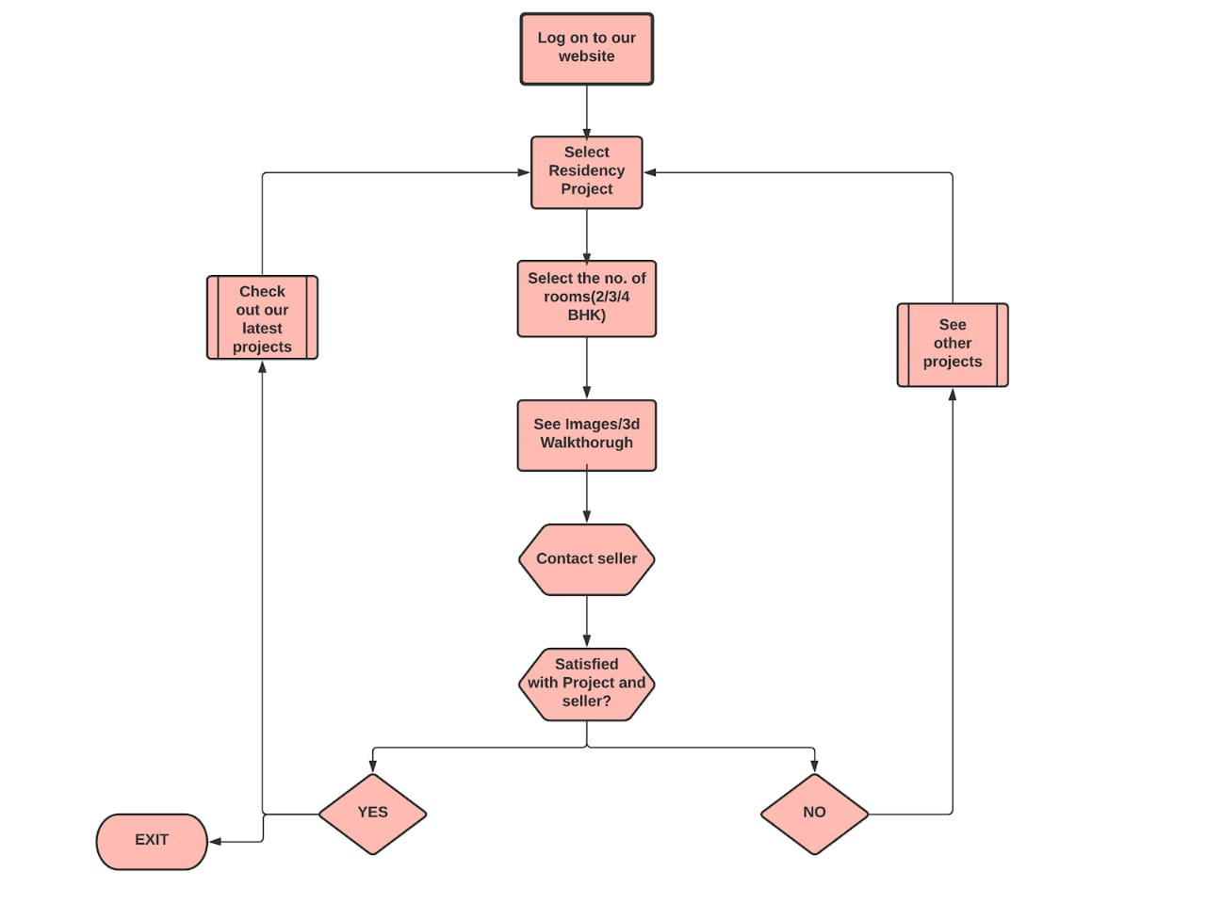

Fig 3.2: Activity Diagram

**3.3 3-D Modelling**

**3.3.1 3-D modelling of house in blender:**

The snapshot in the Fig 3.3 shows the side view of the 3D modelled house in Blender 3D. The walls of house are completed. The roof and furniture are yet to be placed.

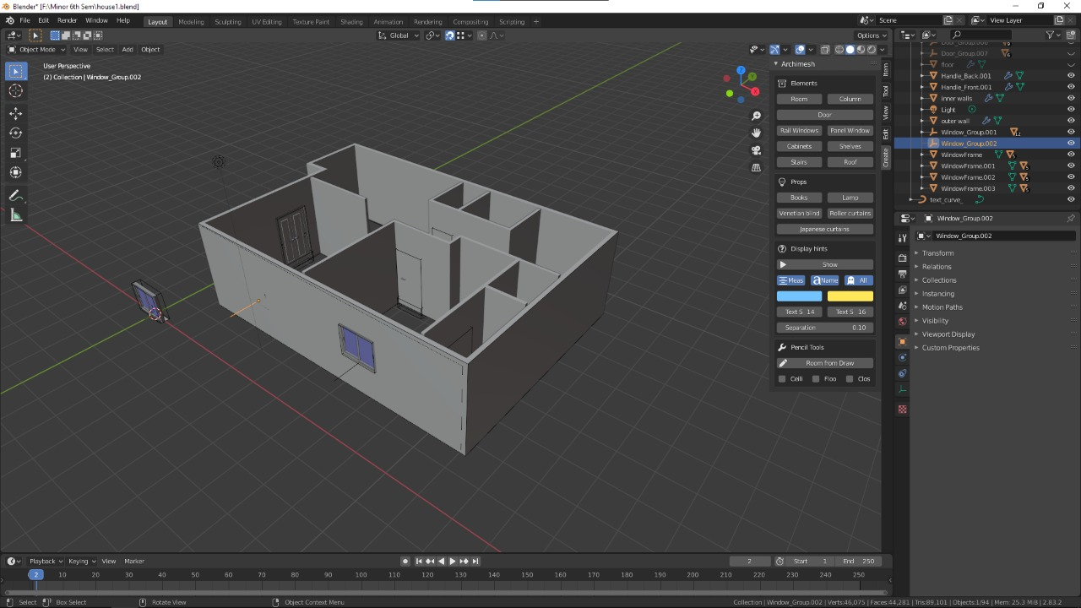

Fig 3.3 Side view of house model (1)

The snapshot in the Fig 3.4 shows another side view of the 3D modelled house in Blender 3D. The walls of house are completed. The roof and furniture are yet to be placed.

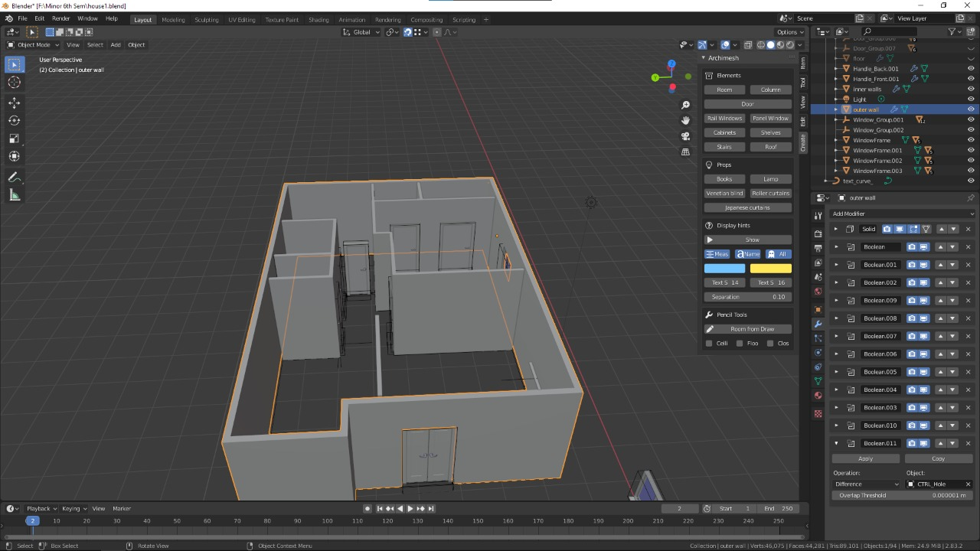

Fig 3.4 Side view of house model (2)

**3.3.2 3D Render of a Demo Unit:**

The snapshot in the Fig 3.5 shows the top view of the 3D modelled house in Blender 3D. This shows the complete layout of the project. The furniture is placed in its position and the house is starting to take shape.

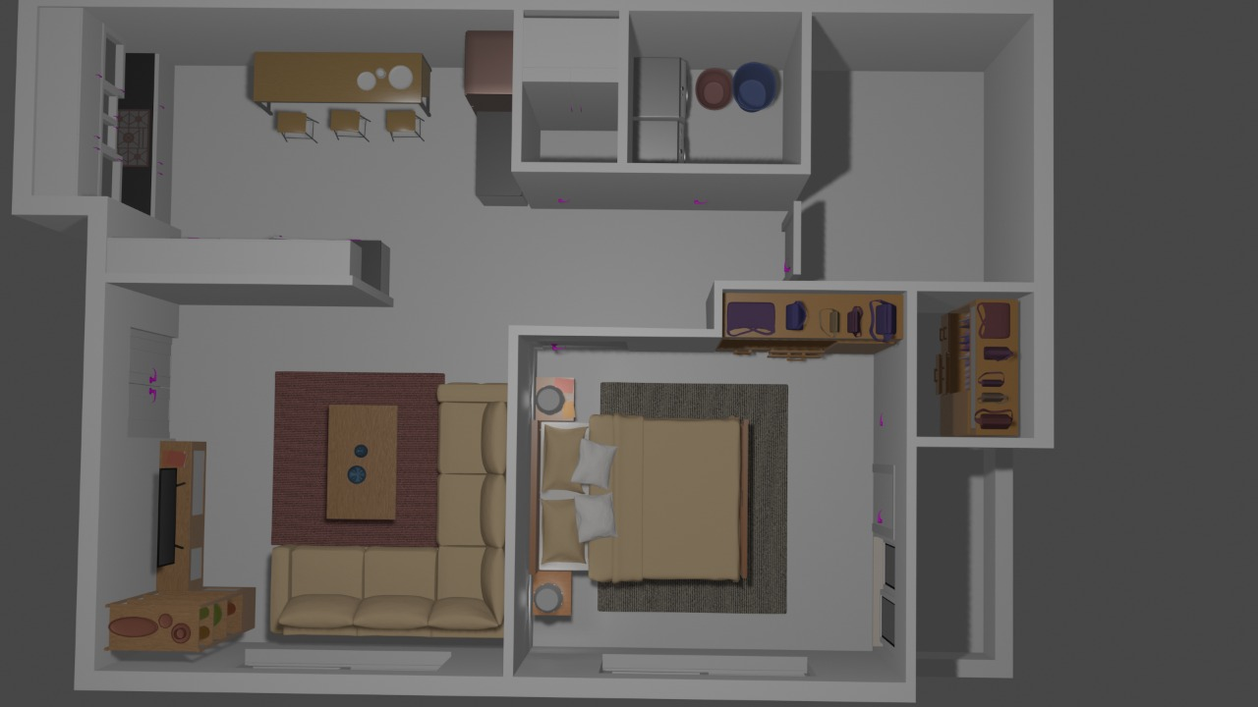

Fig 3.5 Top view of Rendered Model

The snapshot in the Fig 3.6 shows the inside view of the 3D modelled house in Blender 3D. This shows living room and how the furniture like sofa, cupboards, table television will be placed in the actual unit of house.

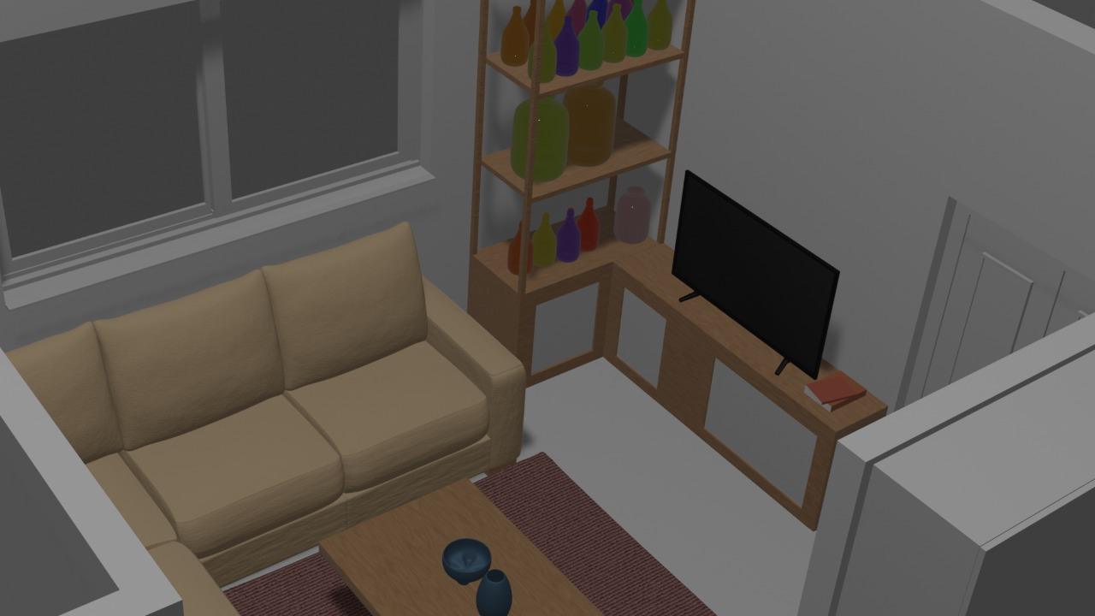

Fig 3.6 Inside view of Rendered Model

**3.3.3 Proposed Output of the House model:**

The image in Fig 3.7 shows how the finished product will look like after the construction is completed. This image will allow the customers to know how the interior of their potential house will look like. All of the interior is fully customizable according to needs.

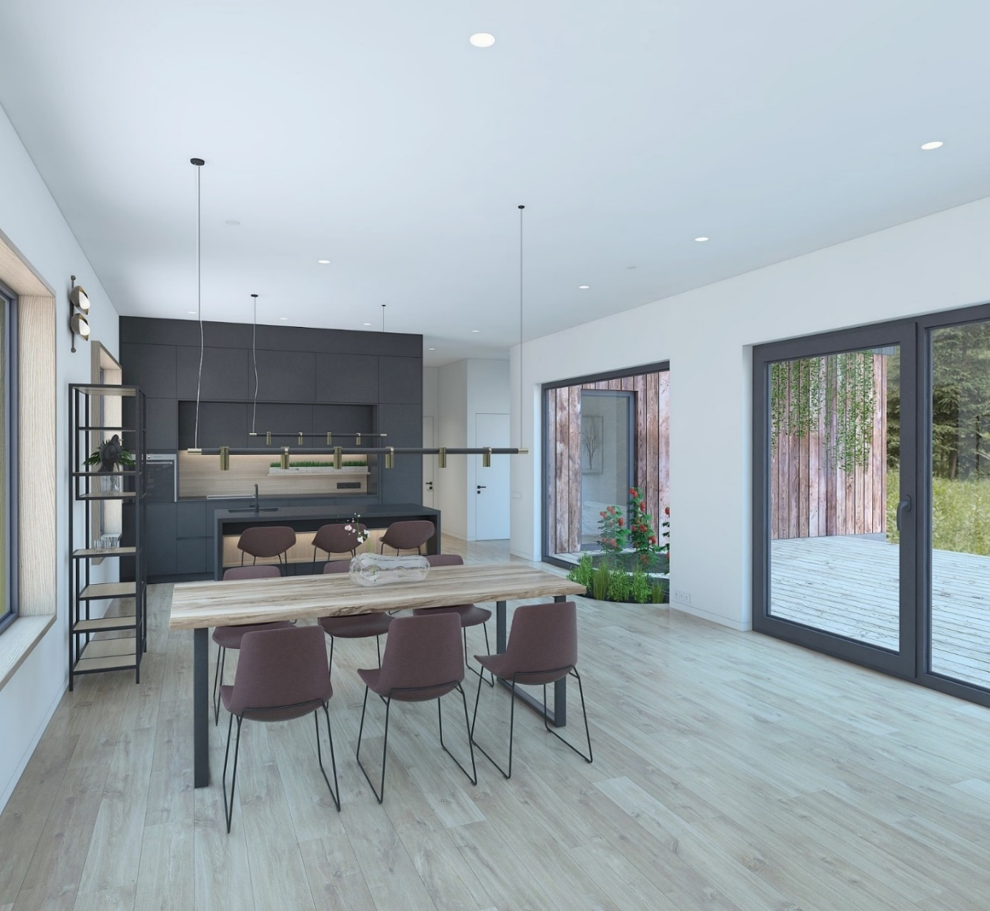

Fig 3.7 Proposed House Model (1)

The image in Fig 3.8 shows how the finished product will look like after the construction is completed. This image shows the living room.

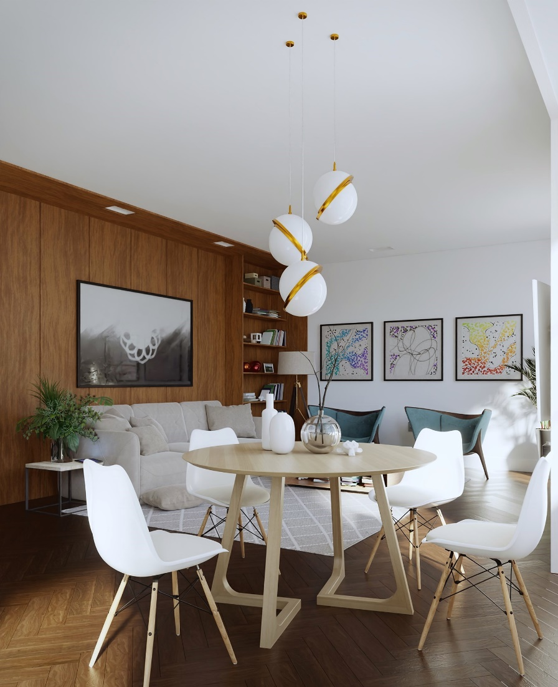

Fig 3.8 Proposed House Model (2)

The image in Fig 3.9 shows how the finished product will look like after the construction is completed. This image shows the view from the dry kitchen into the living room.

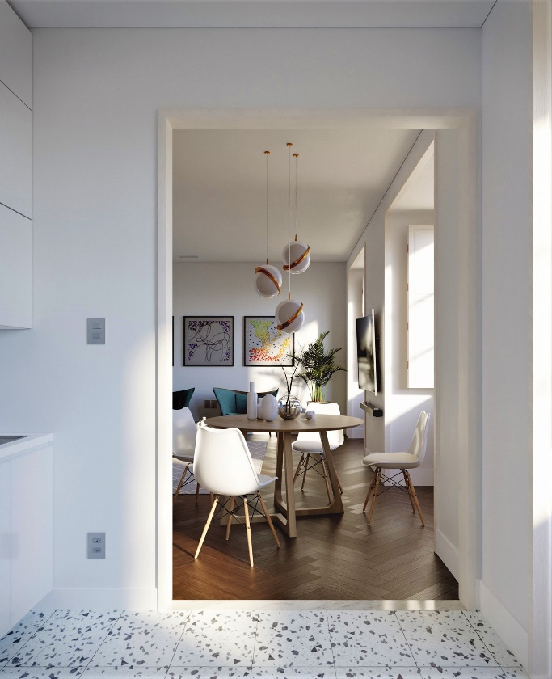

Fig 3.9 Proposed House Model (3)

**CHAPTER 4**

**Website Snapshots**

**4.1 Homepage**

The following screenshots in Fig 4.1 and 4.2 shows the homepage of the website and how it will look for a person if he/she visits for the first time. The UI/UX will be improved in the future as the industry standards.

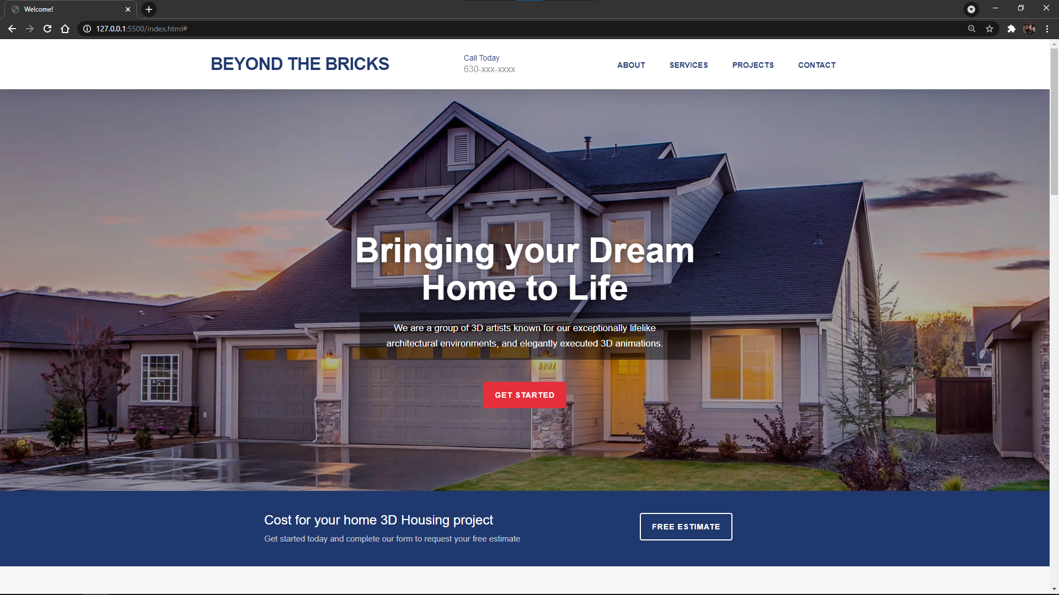

Fig 4.1 Homepage (1)

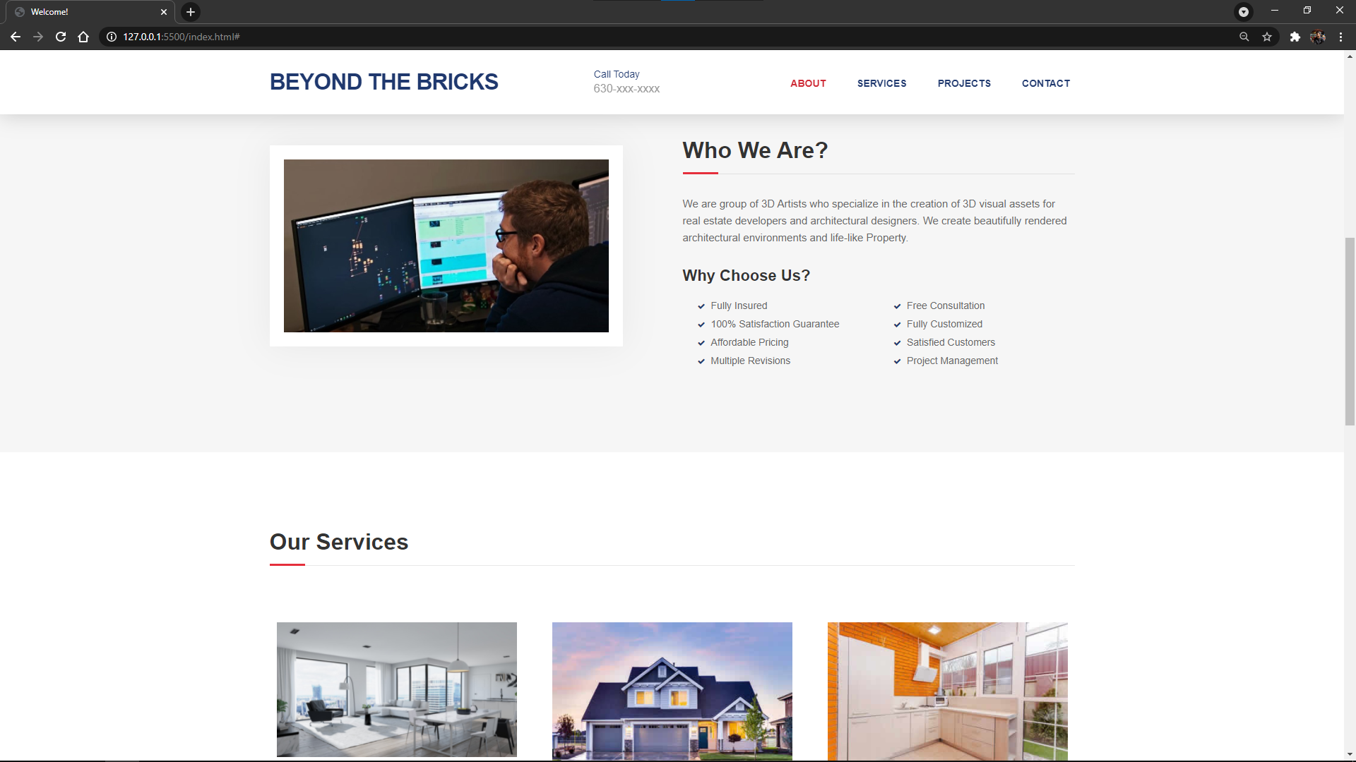Fig 4.2 Homepage (2)

The following screenshots shown in Fig 4.3 shows the contact page of the website. It will allow the users to contact the technical or the corporate team in cases of any issues.

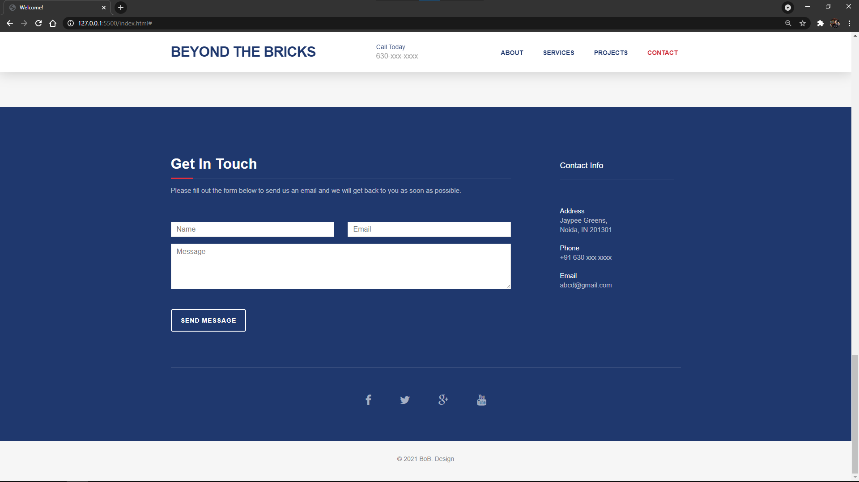

Fig 4.3 Homepage (3)

**4.2 Demo Property**

The following screenshots in Fig 4.4 shows the webpage of a demo unit of the website. The webpage shows the location of the property, the facilities available, project specifications.

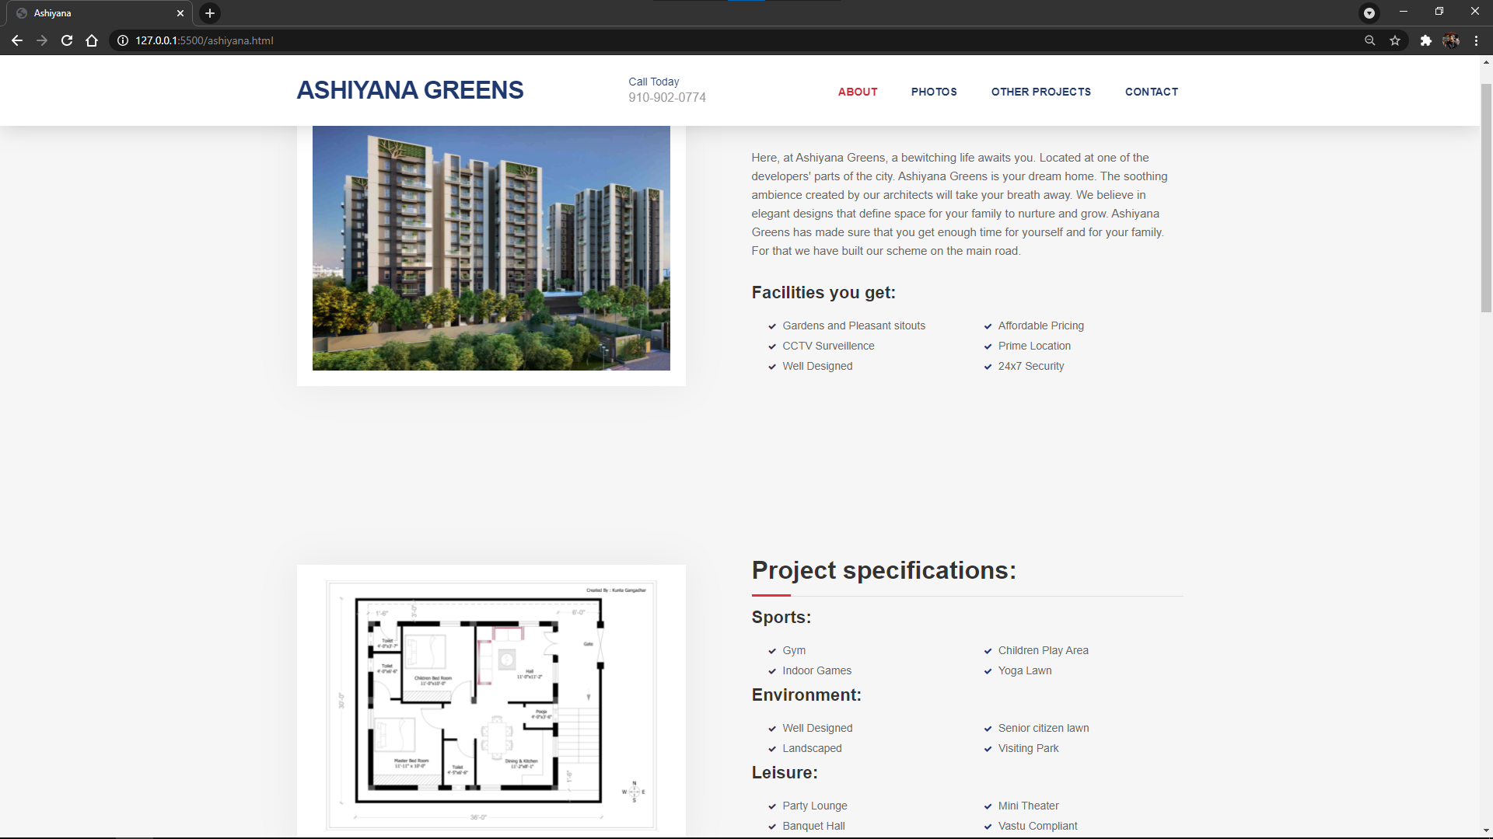

Fig 4.4 Demo Property Webpage

**CHAPTER 5**

**FEATURES AND APPLICATIONS**

**5.1 FEATURES**

**5.1.1 At Home Service**

One of the key Features involve “At Home Service”, this feature omits time consumed to travel from one property to another and lets one compare and view all property at a single platform. Property details and instruction guide provide a different set of view towards a property and the way the experience is enhanced. This reduces unnecessary hassle with property brokers and helps to maintain budget in place.

**5.1.2 Numerous Properties available**

The amount of options available to a person is very huge. People can choose from a variety of options which include different types of properties, different locations, different budgets, etc. This allows people to have satisfaction as they can choose their favorite property from the options and they do not have to rely on some broker to show limited options.

**5.2 APPLICATIONS**

**5.2.1 Architecture Simulation**

The main application is “Architecture Simulation” provides the user with a 3-D view of the whole property with in depth detail about the material used, longevity of the residence and what changes can be done in décor too. It allows the user top see the upcoming property view beforehand.

**5.2.2 Prediction through Machine Learning**

The star attraction of the website will help the user to examine the potential market opinion about the property and with its unique sorting algorithm , based on Machine Learning it will firstly understand your requirement and then will predict the desired properties for the user.

**CHAPTER 6**

**CONCLUSION AND FUTURE SCOPE**

**6.1 Conclusion**

This project is a Real Estate Website with 3-D Model fusion which will be very useful and convenient for users whenever they come to buy any real estate property. So, with this idea and trending technologies like JavaScript and 3-D Modelling and rendering we tried to develop this website that would allow user to look for property in his location and then see all about it and the images. This will further help the sellers to expand their business and will be like a good business growth option.

**6.2 Future Scope**

* We intend to make UI improvements to our website to make it more user friendly.
* We will add share option so that people can share the property of their interest to their family members and friends too.
* We intend to include a map feature which will allow the users to see the location of the property, the shortest route to reach there and the connectivity with necessary places like markets, malls, schools, etc.
* We intend to add sliding bar to our website in the future so as to overlay the 3-D model on the webpage (and no need to open a new webpage every time) and see rendered images and wireframe at the same time.
* We also intend to add a search bar using which people can search the location where they want to buy property.
* We also intend to add a House Price calculator according to their needs
* We can also add a sorting and filtering algorithm according to their respective budgets, locations, type of houses and investment period.

**REFERENCES**

1. ABS (Australian Bureau of Statistics), 2000, *8129.0 Business Use of Information Technology Australia*, [on-line],
2. Adam, S. and Deans, K. R., 2000, “On-line Business in Australia and New Zealand: Crossing a Chasm”, *Ausweb2K Sixth Australian World Wide Web Conference*, Southern Cross University, Lismore, [on-line],
3. Benbasat, I., Goldstein, D. K. and Mead, M., 1987, "The Case Research Strategy in Studies of Information Systems", MIS Quarterly, vol 11, issue 3, pp 369-387, September.
4. Bode, S., and Burn, J., 1999, “SMEs and the Role of Consultants in Establishing e-business: A Case Analysis”, *Proceedings of Collector ‘99*, Victoria University, New Zealand, [on-line],
5. Castleman, T. and Cavill, M., 2001, “e-Everything: e-Commerce, e-Government, e- Household, e-Democracy”, *Proceedings of the 14th Bled Electronic Commerce Conference*, Bled Slovenia, June 25-26, [on-line],

**APPENDIX**

<!DOCTYPE html>

<html lang="en">

<head>

<meta charset="utf-8">

<meta name="viewport" content="width=device-width, initial-scale=1">

<title>Welcome!</title>

<meta name="description" content="">

<meta name="author" content="">

<!-- Favicons

================================================== -->

<link rel="shortcut icon" href="img/favicon.ico" type="image/x-icon">

<link rel="apple-touch-icon" href="img/apple-touch-icon.png">

<link rel="apple-touch-icon" sizes="72x72" href="img/apple-touch-icon-72x72.png">

<link rel="apple-touch-icon" sizes="114x114" href="img/apple-touch-icon-114x114.png">

<!-- Bootstrap -->

<link rel="stylesheet" type="text/css" href="css/bootstrap.css">

<link rel="stylesheet" type="text/css" href="fonts/font-awesome/css/font-awesome.css">

<!-- Stylesheet

================================================== -->

<link rel="stylesheet" type="text/css" href="css/style.css">

<link rel="stylesheet" type="text/css" href="css/nivo-lightbox/nivo-lightbox.css">

<link rel="stylesheet" type="text/css" href="css/nivo-lightbox/default.css">

<link href="https://fonts.googleapis.com/css?family=Open+Sans:300,400,600,700" rel="stylesheet">

<link href="https://fonts.googleapis.com/css?family=Montserrat:400,700" rel="stylesheet">

</head>

<body id="page-top" data-spy="scroll" data-target=".navbar-fixed-top">

<!-- Navigation

==========================================-->

<nav id="menu" class="navbar navbar-default navbar-fixed-top">

<div class="container">

<!-- Brand and toggle get grouped for better mobile display -->

<div class="navbar-header">

<button type="button" class="navbar-toggle collapsed" data-toggle="collapse"

data-target="#bs-example-navbar-collapse-1"> <span class="sr-only">Toggle navigation</span> <span

class="icon-bar"></span> <span class="icon-bar"></span> <span class="icon-bar"></span> </button>

<a class="navbar-brand page-scroll" href="#page-top">Beyond The Bricks</a>

<div class="phone"><span>Call Today</span>630-xxx-xxxx</div>

</div>

<!-- Collect the nav links, forms, and other content for toggling -->

<div class="collapse navbar-collapse" id="bs-example-navbar-collapse-1">

<ul class="nav navbar-nav navbar-right">

<li><a href="#about" class="page-scroll">About</a></li>

<li><a href="#services" class="page-scroll">Services</a></li>

<li><a href="#portfolio" class="page-scroll">Projects</a></li>

<li><a href="#contact" class="page-scroll">Contact</a></li>

</ul>

</div>

<!-- /.navbar-collapse -->

</div>

</nav>

<!-- Header -->

<header id="header">

<div class="intro">

<div class="overlay">

<div class="container">

<div class="row">

<div class="col-md-8 col-md-offset-2 intro-text">

<h1>Bringing your Dream Home to Life</h1>

<p>We are a group of 3D artists known for our exceptionally lifelike architectural environments, and

elegantly executed 3D animations.</p>

<a href="#about" class="btn btn-custom btn-lg page-scroll">GET STARTED</a>

</div>

</div>

</div>

</div>

</div>

</header>

<!-- Get Touch Section -->

<div id="get-touch">

<div class="container">

<div class="row">

<div class="col-xs-12 col-md-6 col-md-offset-1">

<h3>Cost for your home 3D Housing project</h3>

<p>Get started today and complete our form to request your free estimate</p>

</div>

<div class="col-xs-12 col-md-4 text-center"><a href="#contact" class="btn btn-custom btn-lg page-scroll">Free

Estimate</a></div>

</div>

</div>

</div>

<!-- About Section -->

<div id="about">

<div class="container">

<div class="row">

<div class="col-xs-12 col-md-6"> <img src="img/about.jpg" class="img-responsive" alt=""> </div>

<div class="col-xs-12 col-md-6">

<div class="about-text">

<h2>Who We Are?</h2>

<p>We are group of 3D Artists who specialize in the creation of 3D visual assets for real estate developers

and architectural designers.

We create beautifully rendered architectural environments and life-like Property.

</p>

<h3>Why Choose Us?</h3>

<div class="list-style">

<div class="col-lg-6 col-sm-6 col-xs-12">

<ul>

<li>Fully Insured</li>

<li>100% Satisfaction Guarantee</li>

<li>Affordable Pricing</li>

<li>Multiple Revisions</li>

</ul>

</div>

<div class="col-lg-6 col-sm-6 col-xs-12">

<ul>

<li>Free Consultation</li>

<li>Fully Customized</li>

<li>Satisfied Customers</li>

<li>Project Management</li>

</ul>

</div>

</div>

</div>

</div>

</div>

</div>

</div>

<!-- Services Section -->

<div id="services">

<div class="container">

<div class="section-title">

<h2>Our Services</h2>

</div>

<div class="row">

<div class="col-md-4">

<div class="service-media"> <img src="img/services/service-1.jpg" alt=" "> </div>

<div class="service-desc">

<h3>INTERIOR 3D DESIGN & ARCHITECTURE</h3>

<p>Our interior architectural renderings bring every detail to life. We incorporate meticulous detail into

our material applications, ensuring a look and feel that’s as lifelike as possible.</p>

</div>

</div>

<div class="col-md-4">

<div class="service-media"> <img src="img/services/service-2.jpg" alt=" "> </div>

<div class="service-desc">

<h3>EXTERIOR RENDER ARCHITECTURE</h3>

<p>From concept to render, our exterior architectural renderings bring every detail to life. We incorporate

meticulous detail into our material applications, ensuring a look and feel that’s as lifelike as possible.

</p>

</div>

</div>

<div class="col-md-4">

<div class="service-media"> <img src="img/services/service-3.jpg" alt=" "> </div>

<div class="service-desc">

<h3>PERSONAL REBUILDING</h3>

<p>Apart from big projects for Real Estate builders we also make projects directly for customers looking for

home renovation. We make realistic 3D models as per customers view and them pass it on to their

architects.</p>

</div>

</div>

</div>

</div>

</div>

<!-- Gallery Section -->

<div id="portfolio">

<div class="container">

<div class="section-title">

<h2>Our Works</h2>

</div>

<div class="row">

<div class="portfolio-items">

<div class="col-sm-6 col-md-4 col-lg-4">

<div class="portfolio-item">

<div class="hover-bg"> <a href="mayfair.html" title="Project Title" data-lightbox-gallery="gallery1">

<div class="hover-text">

<h4>MayFair Heights</h4>

</div>

<img src="img/portfolio/01-small.jpg" class="img-responsive" alt="Project Title">

</a> </div>

</div>

</div>

<div class="col-sm-6 col-md-4 col-lg-4">

<div class="portfolio-item">

<div class="hover-bg"> <a href="ashiyana.html" title="Project Title" data-lightbox-gallery="gallery1">

<div class="hover-text">

<h4>Ashiyana Greens</h4>

</div>

<img src="img/portfolio/02-small.jpg" class="img-responsive" alt="Project Title">

</a> </div>

</div>

</div>

<div class="col-sm-6 col-md-4 col-lg-4">

<div class="portfolio-item">

<div class="hover-bg"> <a href="sunrise.html" title="Project Title" data-lightbox-gallery="gallery1">

<div class="hover-text">

<h4>Sunrise Projects</h4>

</div>

<img src="img/portfolio/03-small.jpg" class="img-responsive" alt="Project Title">

</a> </div>

</div>

</div>

</div>

</div>

</div>

</div>

<!-- Contact Section -->

<div id="contact">

<div class="container">

<div class="col-md-8">

<div class="row">

<div class="section-title">

<h2>Get In Touch</h2>

<p>Please fill out the form below to send us an email and we will get back to you as soon as possible.</p>

</div>

<form name="sentMessage" id="contactForm" novalidate>

<div class="row">

<div class="col-md-6">

<div class="form-group">

<input type="text" id="name" class="form-control" placeholder="Name" required="required">

<p class="help-block text-danger"></p>

</div>

</div>

<div class="col-md-6">

<div class="form-group">

<input type="email" id="email" class="form-control" placeholder="Email" required="required">

<p class="help-block text-danger"></p>

</div>

</div>

</div>

<div class="form-group">

<textarea name="message" id="message" class="form-control" rows="4" placeholder="Message"

required></textarea>

<p class="help-block text-danger"></p>

</div>

<div id="success"></div>

<button type="submit" class="btn btn-custom btn-lg">Send Message</button>

</form>

</div>

</div>

<div class="col-md-3 col-md-offset-1 contact-info">

<div class="contact-item">

<h4>Contact Info</h4>

<p><span>Address</span>Jaypee Greens,<br>

Noida, IN 201301</p>

</div>

<div class="contact-item">

<p><span>Phone</span> +91 630 xxx xxxx</p>

</div>

<div class="contact-item">

<p><span>Email</span> abcd@gmail.com</p>

</div>

</div>

<div class="col-md-12">

<div class="row">

<div class="social">

<ul>

<li><a href="#"><i class="fa fa-facebook"></i></a></li>

<li><a href="#"><i class="fa fa-twitter"></i></a></li>

<li><a href="#"><i class="fa fa-google-plus"></i></a></li>

<li><a href="#"><i class="fa fa-youtube"></i></a></li>

</ul>

</div> </div>

</div> </div> </div>

<!-- Footer Section -->

<div id="footer">

<div class="container text-center">

<p>&copy; 2021 BoB. Design</p>

</div>

</div>

<script type="text/javascript" src="js/jquery.1.11.1.js"></script>

<script type="text/javascript" src="js/bootstrap.js"></script>

<script type="text/javascript" src="js/SmoothScroll.js"></script>

<script type="text/javascript" src="js/nivo-lightbox.js"></script>

<script type="text/javascript" src="js/jqBootstrapValidation.js"></script>

<script type="text/javascript" src="js/contact_me.js"></script>

<script type="text/javascript" src="js/main.js"></script>

</body>

</html>